write a pl/sql program to display particular employee , empNo, empName ,sal,commistion ,gross sal and deptno?

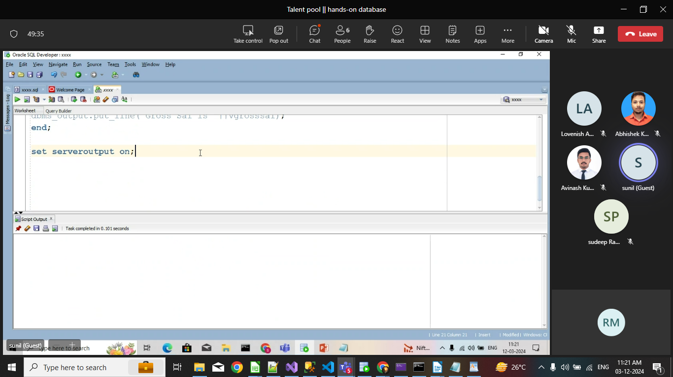
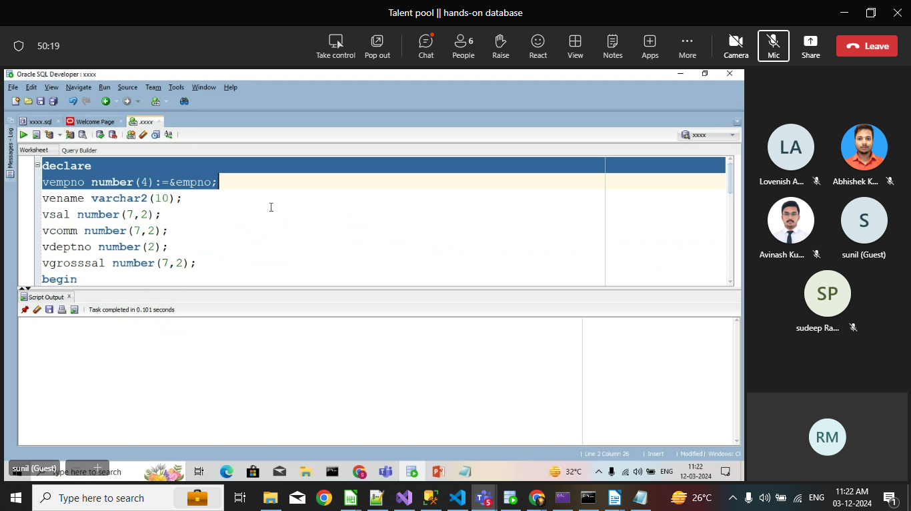
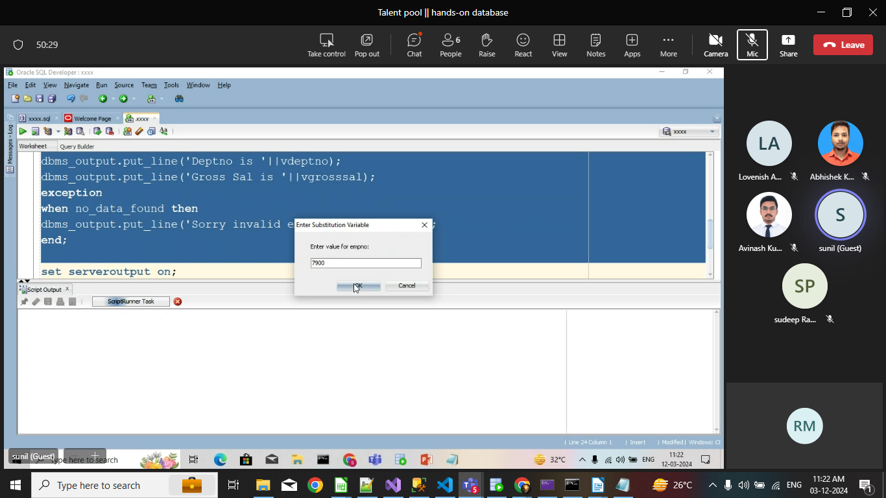
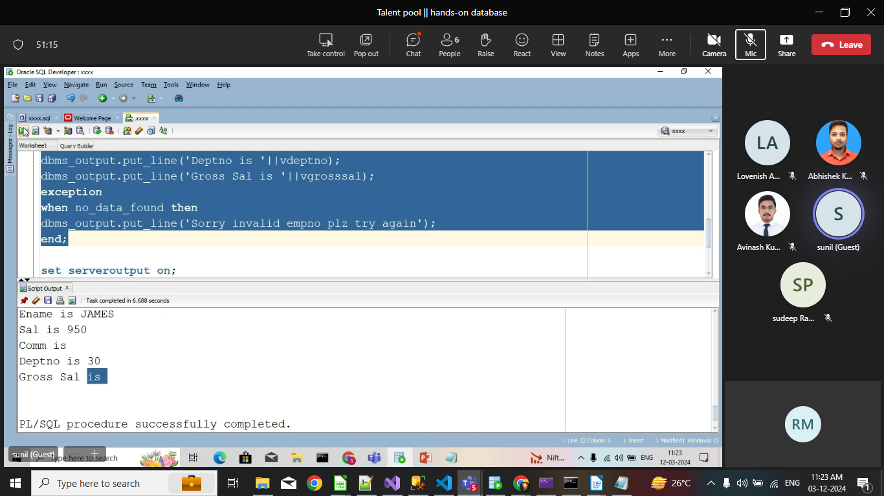
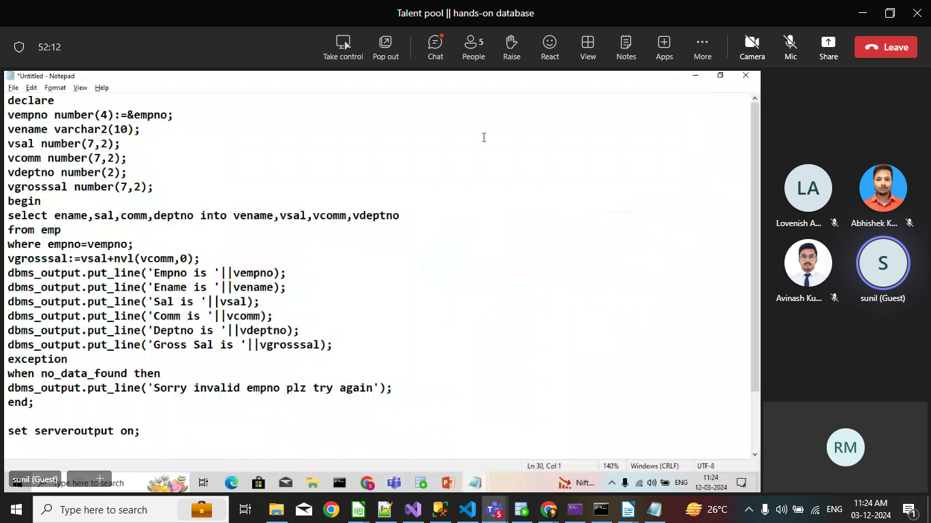
Q.write a pl/sql to print particular emplyees empno,empName,sal, location ,dptno,dptName and sal grade?

